1.
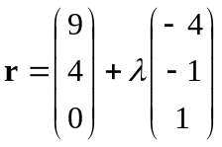 when 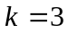.

2.
52757173

3.
Prove by mathematical induction.

4.
(i) 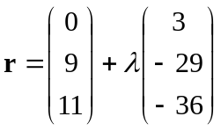
(ii) 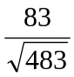
(iii) 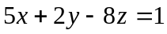

5.
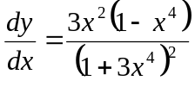, local minimum point : 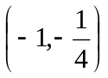, local maximum point : 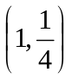, inflexion point : 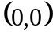

6.


